PatLast, PatFirst (PatDOB)
PatMRN
02/17/2012

.P:HISTORY OF PRESENT ILLNESS
The patient is a very pleasant 00-year-old (male/female) who presents for evaluation.

Past medical history, allergies, medications, past surgical history, family history, social history, review of systems were reviewed as per the patient's self-report on our standard health history form.

«TEXT_BODY_VR»
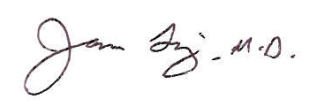
James Ting, M.D.

DicInit:EditID

Dictated but not proofread.

cc:

